Hi All,

Intent of this document is, to help you with necessary details required at the initial stage to setup access to e-learning platforms offered by Capgemini.

This document also lists down the mandatory learnings that you need to complete during your training period, by efficiently utilizing the following Saturdays in your training schedule.

IMP: To be able to perform all the actions listed below seamlessly, you must need to have a valid official Corp ID/Email ID and an activated/working Mobile Pass Application. (Please refer the given screenshots for reference)

1. **NEXT Platform Registration:**
2. Access NEXT using this URL - https://degreed.com /?orgsso=Capgemini
3. Set Your Roles – Associate/Software engg. (This is allowed to edit in future as per need.)

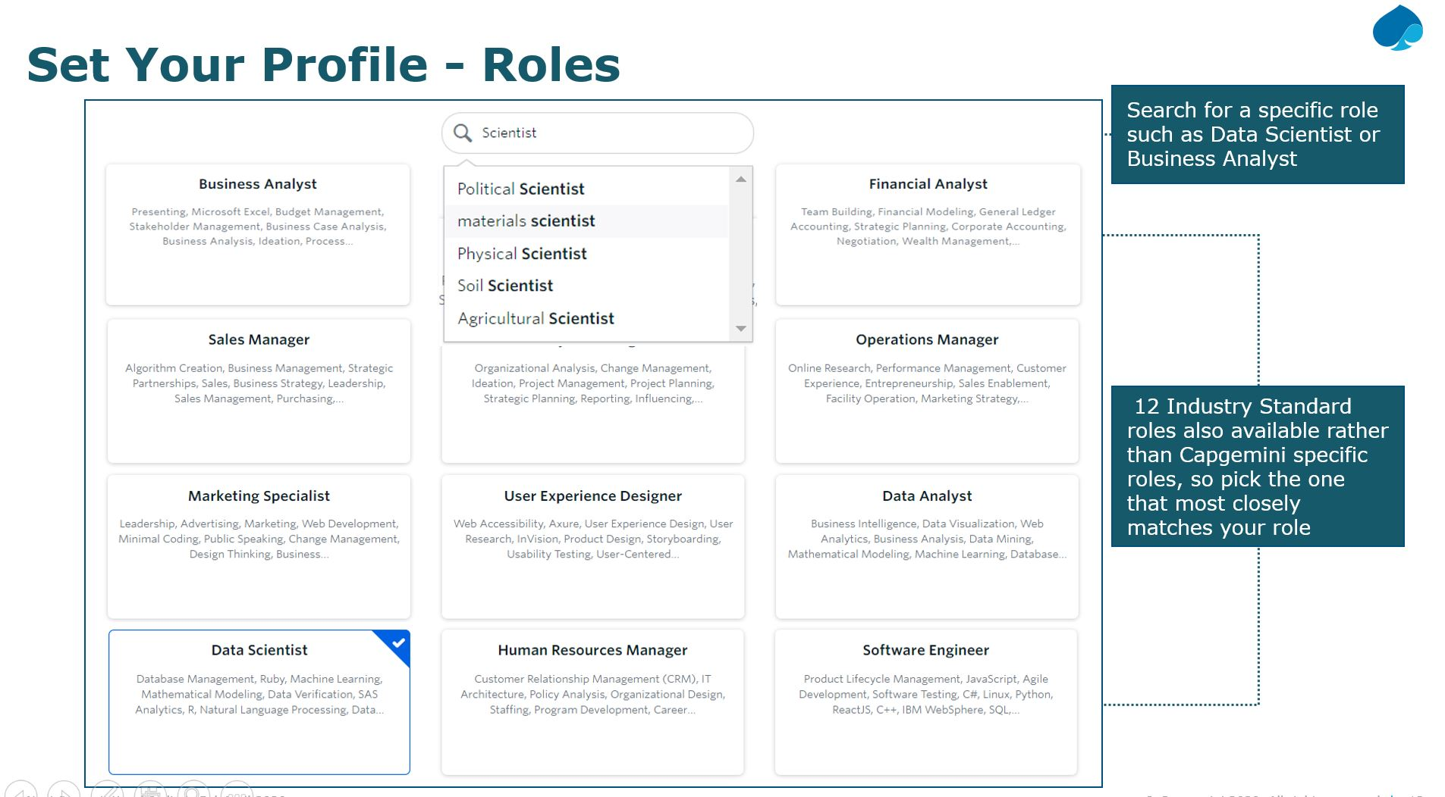

1. Set Your Skills – Minimum 3 skills to be identified (Suggestion: Select as per domain/technology you have been mapped to.)

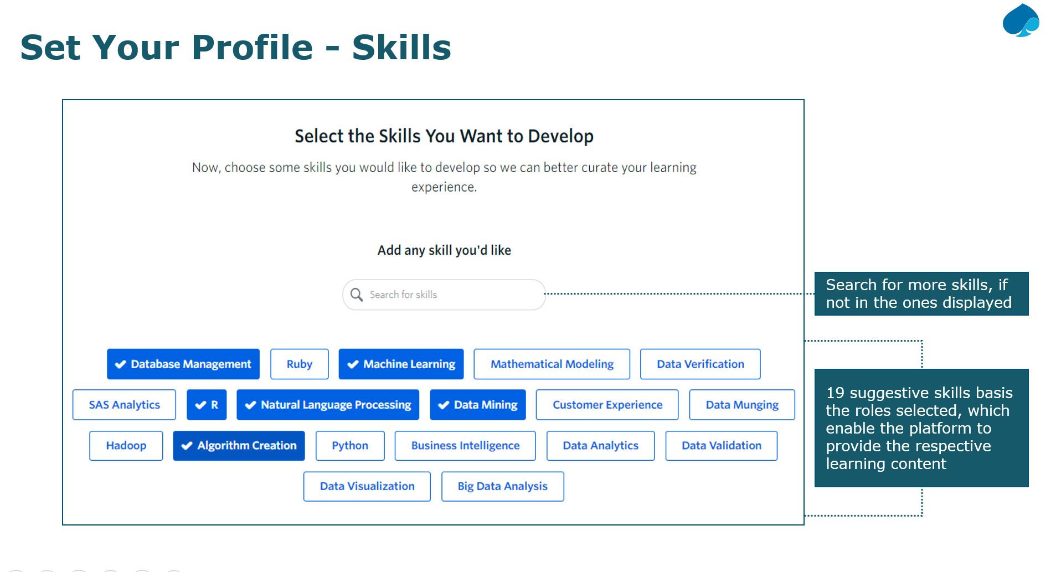

1. Set Self Rating for the selected skills ( As per your current knowledge level of that skill )

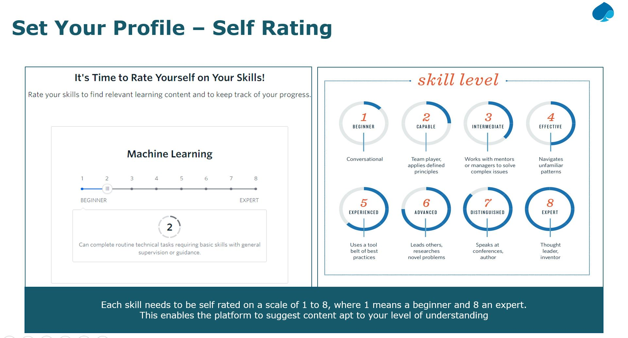

Once all steps competed successfully, you will land on Home page/ dashboard of NEXT.

(Your very own customized profile view, ready to leverage)

-----------------------------------------------------------------------------------------------------------------------------------------------------------

1. **How learning happens on NEXT? Below image for reference, to find out the answer☺.**

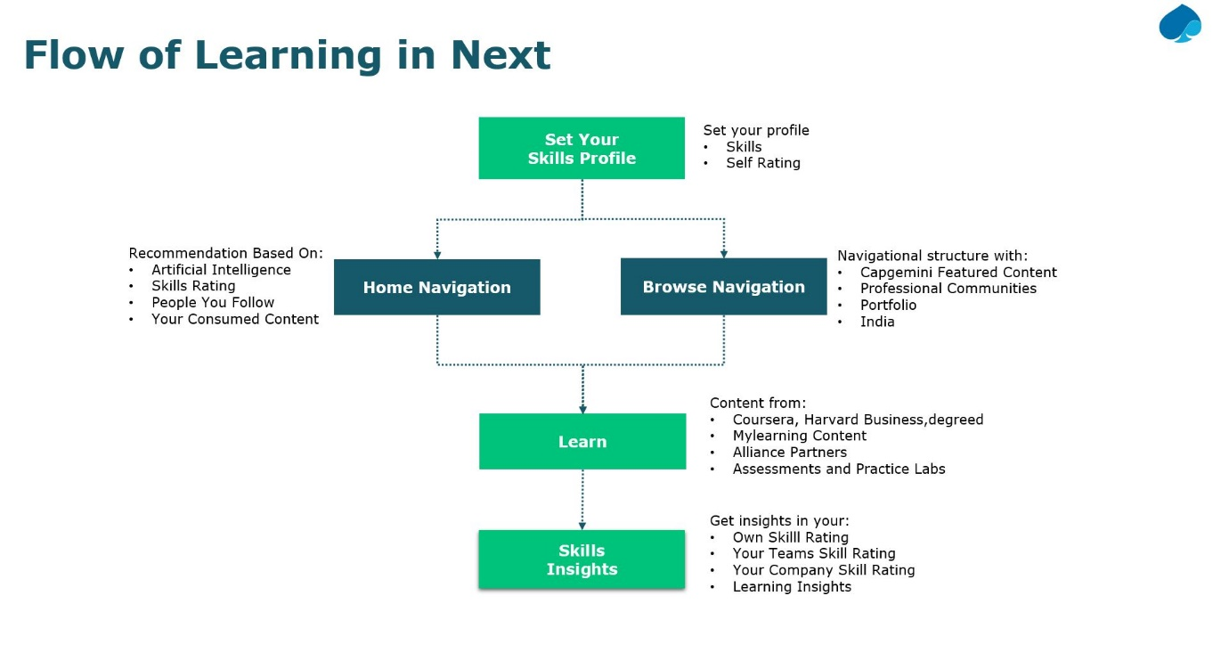

**----------------------------------------------------------------------------------------------------------------------------------------------**

1. **Registration for Pluralsight:**
2. Access - [https://degreed.com/learning#/browse](https://degreed.com/learning)
3. Navigate to **Featured** Providers & select Pluralsight
4. Click on any of the video of Pluralsight(Navigates to Website)
5. Create an account by using Capgemini email id on Pluralsight website

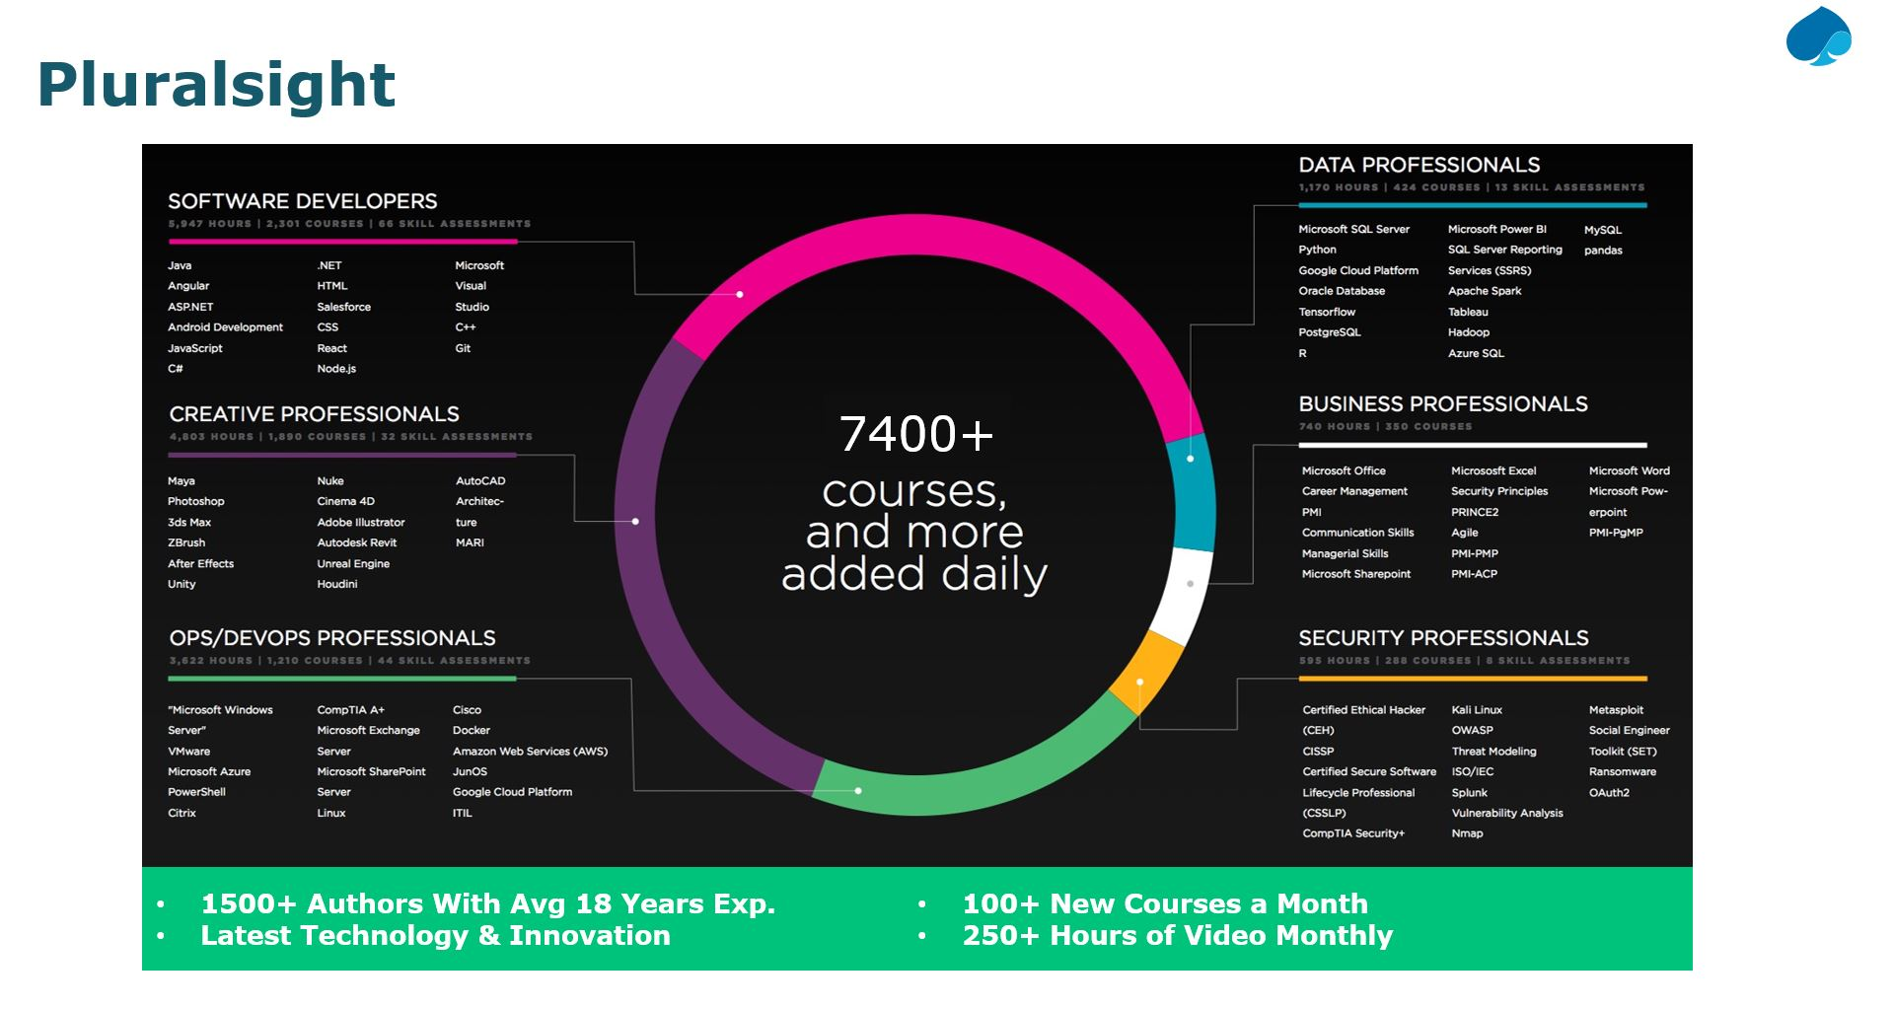

1. **Registration for GARI:**
2. Go to Talent - <https://talent.capgemini.com/in>
3. Select MyLearning - Listed under Global Links

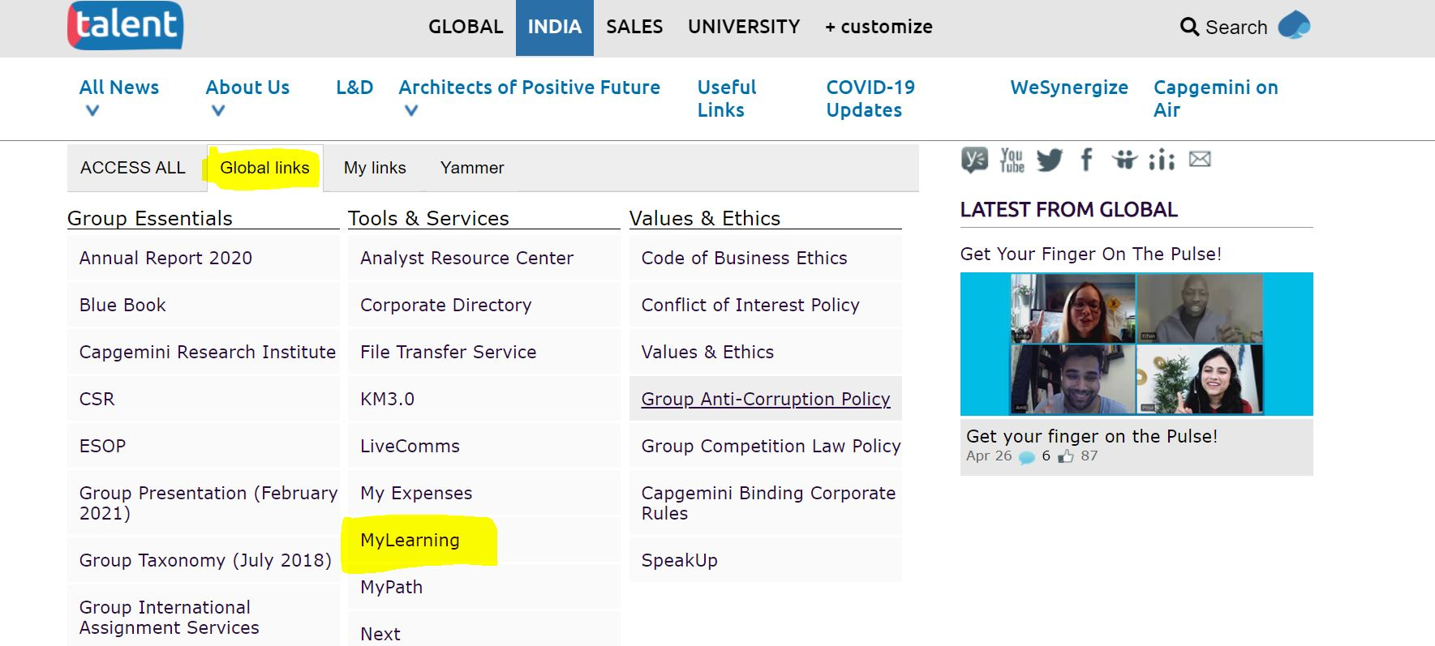

1. Click on GARI on MyLearning Page

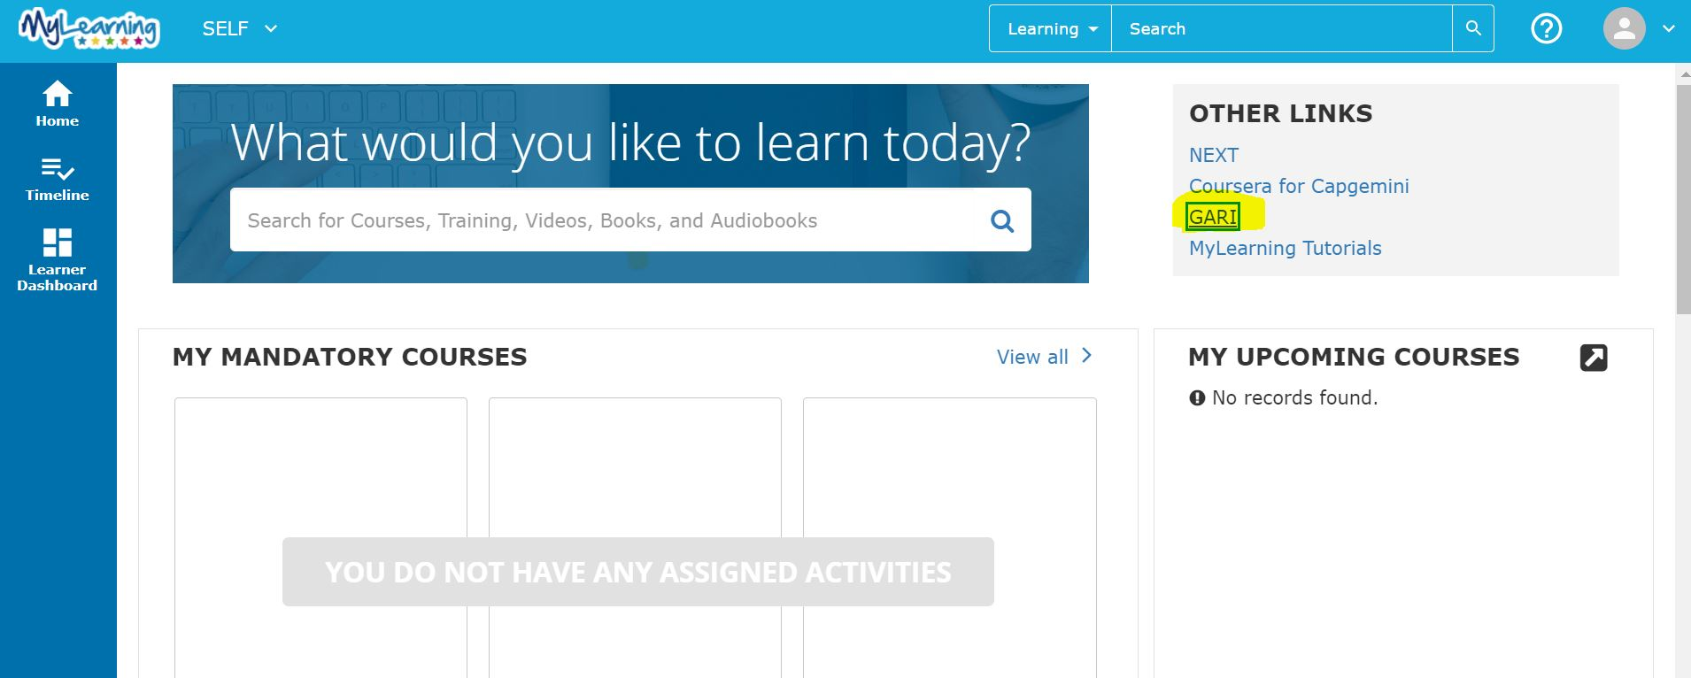

1. Key in at least one skill on popup window (then click on validate/submit)

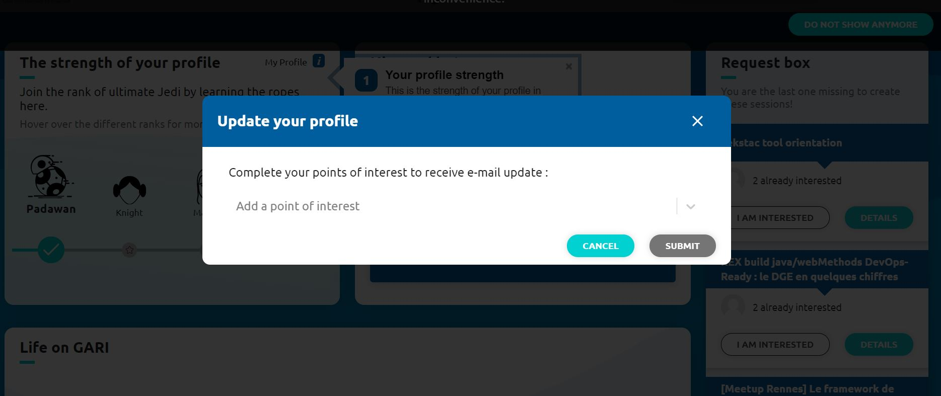

1. **Mandatory E-Learning Details:**

Please follow below link to find the details.

[Mandatory ELearnings.xlsx](Mandatory%20ELearnings.xlsx)

**For any queries related to login or registration errors, request you to please raise ticket on Service central and follow up with IT support team for the closure/ call the Group IT services to seek the possible solution.**